MSFileReader 2.2 Installation Instructions
The setup for the MSFileReader library was created with the InstallShield 2009 version. It implements the x86 and x64 libraries for fileio.dll, fregistry.dll and XRawFile2.dll. The “MSFileReader_Reference.pdf” document will also be installed onto the target system during the setup procedure.
The instructions for installing MSFileReader 2.2 on a 32 bit and a 64 bit system are below.
Installation on a 32 bit system
Launch MSFIleReader.exe on an x86 target system.
Follow the instructions to install the MSFileReader application.
Installation on a 64 bit system
Launch MSFIleReader.exe on an x64 target system. During the installation, you will be allowed to choose whether to install the 32 bit version, the 64 bit version, or both.
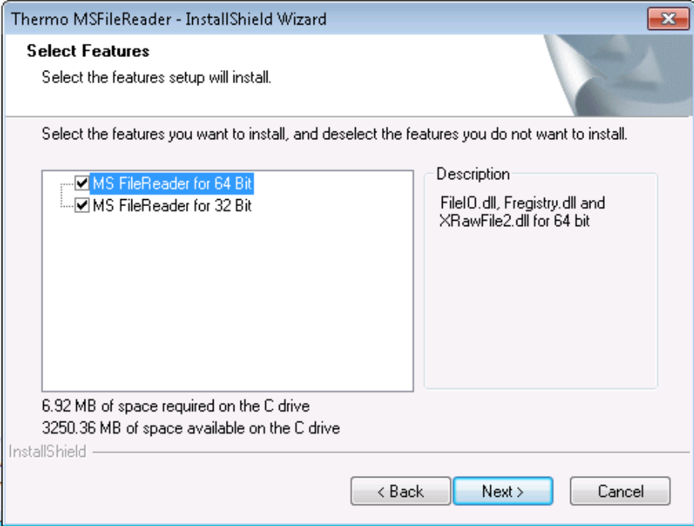

If “MS FileReader for 64 Bit” is selected, the 64 bit version of the required libraries and Reference Guide are installed into the “PROGRAM FILES\Thermo\MSFileReader” folder. If “MS FileReader for 32 Bit” is selected, the 32 bit version of required libraries and Reference Guide are installed into the “PROGRAM FILES (x86)\Thermo\MSFileReader” folder. If both are selected, the required libraries and Reference Guide are installed in both locations.

Command Shell parameter

The MSFileReader installer can be launched from a command shell. For this mode of installation the following flags are defined:

- “-x86” -> Installs the fileIO.dll, fregistry.dll and XRawfile2.dll for a x86 system on the target machine.
- “-x64” -> Installs the fileIO_64.dll, fregistry_64.dll and XRawfile2_64.dll for a x64 system on the target machine.

The user can choose one or both of these flags in a command line to install the specific version of the MSFileReader libraries on the target machine.

Example : To install both version of MSFiIeReader libraries into the “PROGRAM_FILES_FOLDER\Thermo\MSFileReader” path, and register the x64 bit of XRawFile2.dll, launch a command shell and type:
MSFileReader.exe –x86 –x64
And then press the “Yes” button when the “Question” dialog appears on the desktop during the setup procedure.

